KEEP BRITAIN TIDY NEWS RELEASE:
Embargoed until 08:00am (BST), Wednesday 20th September 2023
*Associated photos for this Press Release will be uploaded to the shared folder HERE
** Green Flag Award publicity guidance is available here
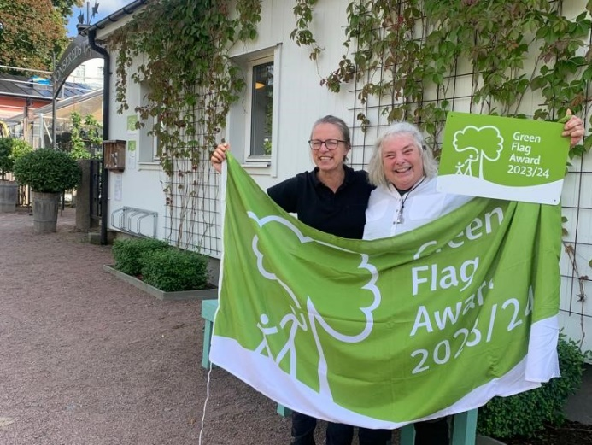
Cover image: Jonsereds Trädgårdar (Jonsered's Garden) in Partille, Sweden receives a surprise delivery from the judges.
TITLE:
Over 150 European parks and green spaces win coveted Green Flag Award
SUBTITLE:
A record number of parks and green spaces in Europe have won the international Green Flag Award in 2023
Parks and green spaces in Austria, Belgium, Finland, France, Germany, Ireland, The Netherlands, Portugal, Spain, Sweden and Turkey were accredited with the coveted Award - including many first-time winners.
Kurpark Warmbad-Villach became the first park in Austria to win the Award, whilst in Finland parks saw a more than 50% increase in winners including Hupisaarten kaupunginpuisto in the far northern city of Oulu.
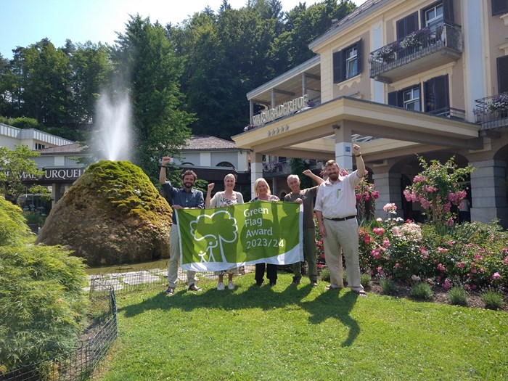
Image 2: Kurpark Warmbad celebrates the first Green Flag Award in Austria.
Robert Walton – Head of the gardening team at Kurpark Warmbad-Villach said:
"Winning the Green Flag Award means so much to me and the staff that help to maintain the park. It demonstrates that we have an inviting environment, which creates a positive benefit for our visitors, employees and the local community.”
Europe's Liveable Cities
Câmara Municipal do Porto in Portugal leads the way in Southern Europe with a new winner - Jardins do Palácio de Cristal (Crystal Palace Gardens), bringing a 3rd Award under their management for the City of Porto. And many other European cities continue to use the Award to celebrate multiple parks or green spaces of importance in their communities.
Nantes was the first city in France to achieve the Award and has won again for the 3rd year running for three sites. Antwerp has an impressive seven winners in the city region. Kotka in Finland holds five Awards, and Dublin boasts more than 30 in the surrounding area.

Green Heritage Site Accreditation is awarded to Green Flag Award winning sites that actively understand, identify, manage and promote the elements of their heritage that make that site unique. This year in Europe 13 sites were awarded with this accolade – one in Portugal and 12 in Ireland.
Ireland also continues to demonstrate a passion for people power - as 17 sites won Green Flag Community Award for places managed by volunteers, community groups or charitable trusts. On top of this, 84 parks and green spaces in Ireland won a Green Flag Award, recognising the hard work of local authorities and parks management organisations.
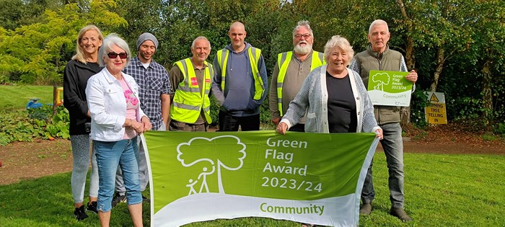
Image 3: Committee members and volunteers from Community Award winning Julianstown Community Garden.
Emlyn Cullen – Programme Manager for An Taisce Environmental Education Unit, who run the Award in Ireland said:
‘The continued success of the Green Flag Award is due to the love that staff members have for their parks, and the hard work they put in to maintaining them. They do a phenomenal job every day making their parks beautiful, safe spaces for the public to enjoy.’
Internationally recognised
The Green Flag Award is the international quality benchmark for the public green space sector - now operating in 17 countries around the world. Running for over 25 years, the programme uses eight key criteria headings to for assessments. Both the management framework for each site, as well as an annual condition inspection is conducted through a network of qualified judges. So far in the past twelve months over 2,400 sites have received annual accreditation.
In July the UK, where the programme originated, announced a record breaking 2,216 winners this year. Further announcements are scheduled later in 2023 for more winners in Australia, Mexico, New Zealand, USA and the United Arab Emirates.
Carl McClean, International Development Manager for the Green Flag Award said:
“Well done to every single person involved in managing, maintaining, supporting, or volunteering at one of these Green Flag Award winning places. This Award recognises your hard work and commitment all throughout the year.”
“It’s fantastic to see so many European parks achieve well-deserved international recognition with a Green Flag Award. Parks continue to benefit both people and planet in so many different ways, and the sector deserves recognition for making that possible.”
Global winners
For an interactive global map of current winners, visit: https://www.greenflagaward.org/award-winners/
Further information
The Green Flag Award® is a non-profit international accreditation programme that recognises and rewards well managed parks and green spaces. Today the Green Flag Award proudly flies above more than 2,400 places in 17 countries around the world.
The programme is managed internationally by environmental Charity Keep Britain Tidy, alongside a network of National Operators in several countries. See the website Network page for more information.
To find out more in general, or apply for an Award, whichever country you are based in; explore the Green Flag Award website: https://www.greenflagaward.org, or alternatively click here for a contact form.

ENDS
Notes to editors

The Green Flag Award programme (http://greenflagaward.org/) is managed by the environmental charity Keep Britain Tidy, under licence from the UK Department for Levelling Up, Housing and Communities, in partnership with a number of National Operators from around the world.

Any green space that is freely accessible to the public is eligible to enter for a Green Flag Award. Awards are given on an annual basis and winners must apply each year to renew their Green Flag Award status. A Green Flag Community Award recognises quality sites managed by voluntary and community groups. Green Heritage Site accreditation is judged on the treatment of the site’s historic features and the standard of conservation.
Keep Britain Tidy is a leading environmental charity. We set the standard for the management of parks and beaches, inspire people to be litter-free, to waste less and live more sustainably. We run campaigns and programmes including, Love Parks, the Green Flag Award for parks and green spaces, the Blue Flag/ Seaside Awards for beaches, Green Key for sustainable hospitality and tourism, the Great British Spring Clean and Eco-Schools. To find out more about Keep Britain Tidy, our campaigns and programmes visit www.keepbritaintidy.org.

Press enquiries
Contact the Keep Britain Tidy press office:
Helen Bingham helen.bingham@keepbritaintidy.org
Keep Britain Tidy Mobile: 07768 880016

